**RESUME**

Abita Ann Augustine 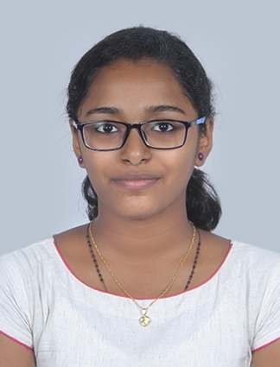

[abitaaugustine@gmail.com](mailto:abitaaugustine@gmail.com)

+91-8156998145

Thodupuzha, Kochi

CAREER OBJECTIVE To use my skills and ability for technical and career advancements.

EDUCATION Bachelor of Technology (B.Tech), Computer Science(2016-2020)

APJ Abdul Kalam Technological University(RAJIV GANDHI INSTITUTE OF TECHNOLOGY, KOTTAYAM)

XII (Senior Secondary),Science

Year of Completion: 2016

CBSE Board (De Paul Public School,Thodupuzha)

Percentage: 93.20%

X (Secondary)

Year of Completion: 2014

CBSE Board (De Paul Public School,Thodupuzha)

CGPA: 10/10

POSITIONS OF **\***IEEE Student Member

RESPONSIBILITY **\***Member of IEEE Computer Society

**\***Member of IEEE Women In Engineering

TRAININGS Android Application Development

IEEE INNOVANCE 2.0(GOVERNMENT ENGINEERING COLLEGE, THRISSUR)

FEB 2017 - FEB 2017

The two day workshop involved in the development of an Android application using Android Studio. At the end of the workshop an app to convert inches to centimetres was made.

Workshop on HTML, CSS, JavaScript ;Talk on Microsoft Azure;

Workshop on Mobile Development using Ionic

IEEE ISQIP(COLLEGE OF ENGINEERING,CHENGANNUR)

JUN 2017 - JUN 2017

A week long internship training program that involved a two day workshop on website development using HTML, CSS and Javascript, a one day session on Microsoft Azure and a three day session on Mobile Development using Ionic

PROJECTS Guess the number game using Python

Nov 2016 – Dec 2016

Did a project for which we made a guess the number game using python during the

first semester of B.Tech.

Student Report using C++

Jan 2016 – Mar 2016

Did a project on the Student Report for the students of a class using C++ as the main projectin class 12.

SKILLS C++ Programming JavaScript

C Programming CSS PYTHON SQL

HTML MS-Excel

MS-Word MS-Powerpoint

Linux Windows 10

Windows 8 Windows 7

ADDITIONAL *Participated in National Mathematics Olympiad Contest held by All India Schools DETAILS Mathematics Teachers Association and secured 90% marks.

**\***Was the Purple Pupil from the class for the year 2015-2016

**\***Secured second place in school level Science Quiz.

**\***Secured second place in Anchoring-English and third place in Extempore-Hindi held in connection with School Arts Fest.

**\***Volunteered in IEEE events

PERSONAL Address

DETAILS Nanthalath (H),

Vazhithala P.O,

Thodupuzha,

Idukki,

Kerala,

685583

Date of Birth

23/01/1999

Gender

Female

Marital Status

Single

Languages Known

English, Hindi, Malayalam